Setup Google drive with n8n  
  
Loom for sheet logic - <https://www.loom.com/share/c833eb8bfa4a4d8697d95b0044f2b5a4?sid=a5caa977-0c96-4e62-904d-97e9a3c484b7>

**Step 1: Google cloud console**

- Go to Google cloud console  
- Create a new project

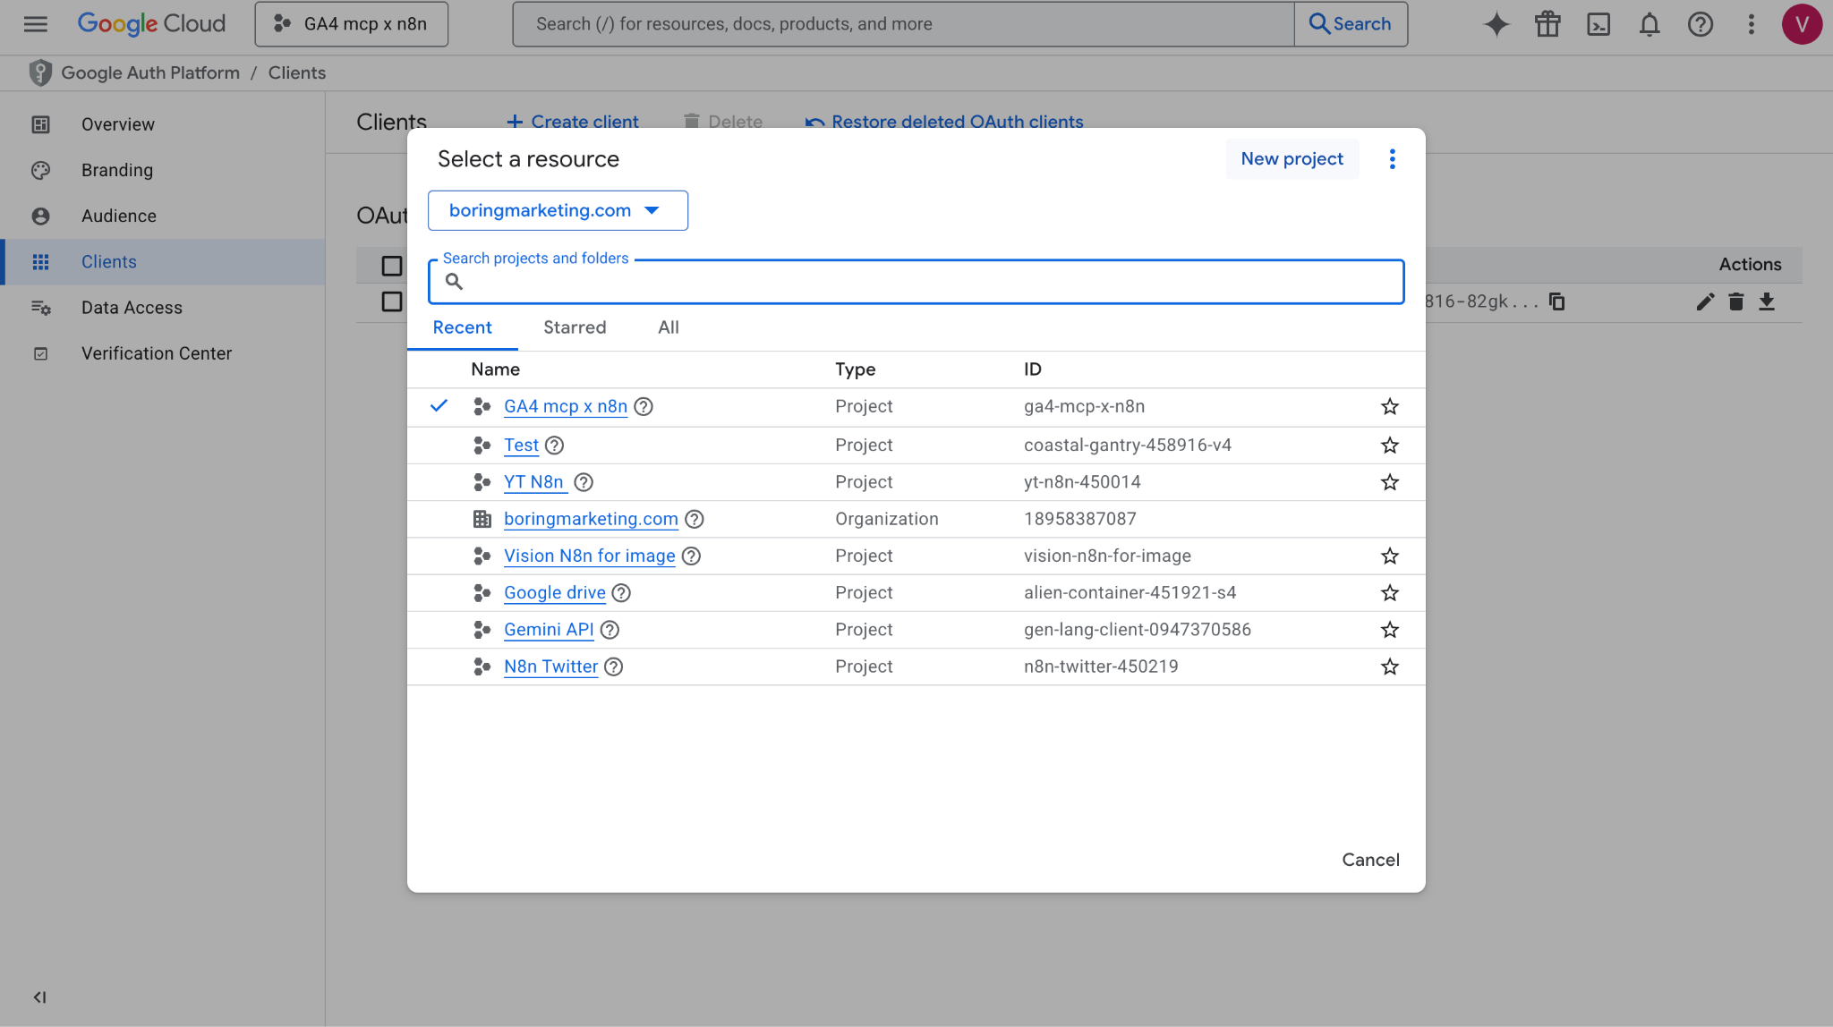  
  
  
**Step 2: Oauth2 creation**  
  
- Go to API library and select google sheet

- Enable Google sheets API  
- Keep the client secret, client id from the Oauth2   
- Make sure you enable Google drive API too

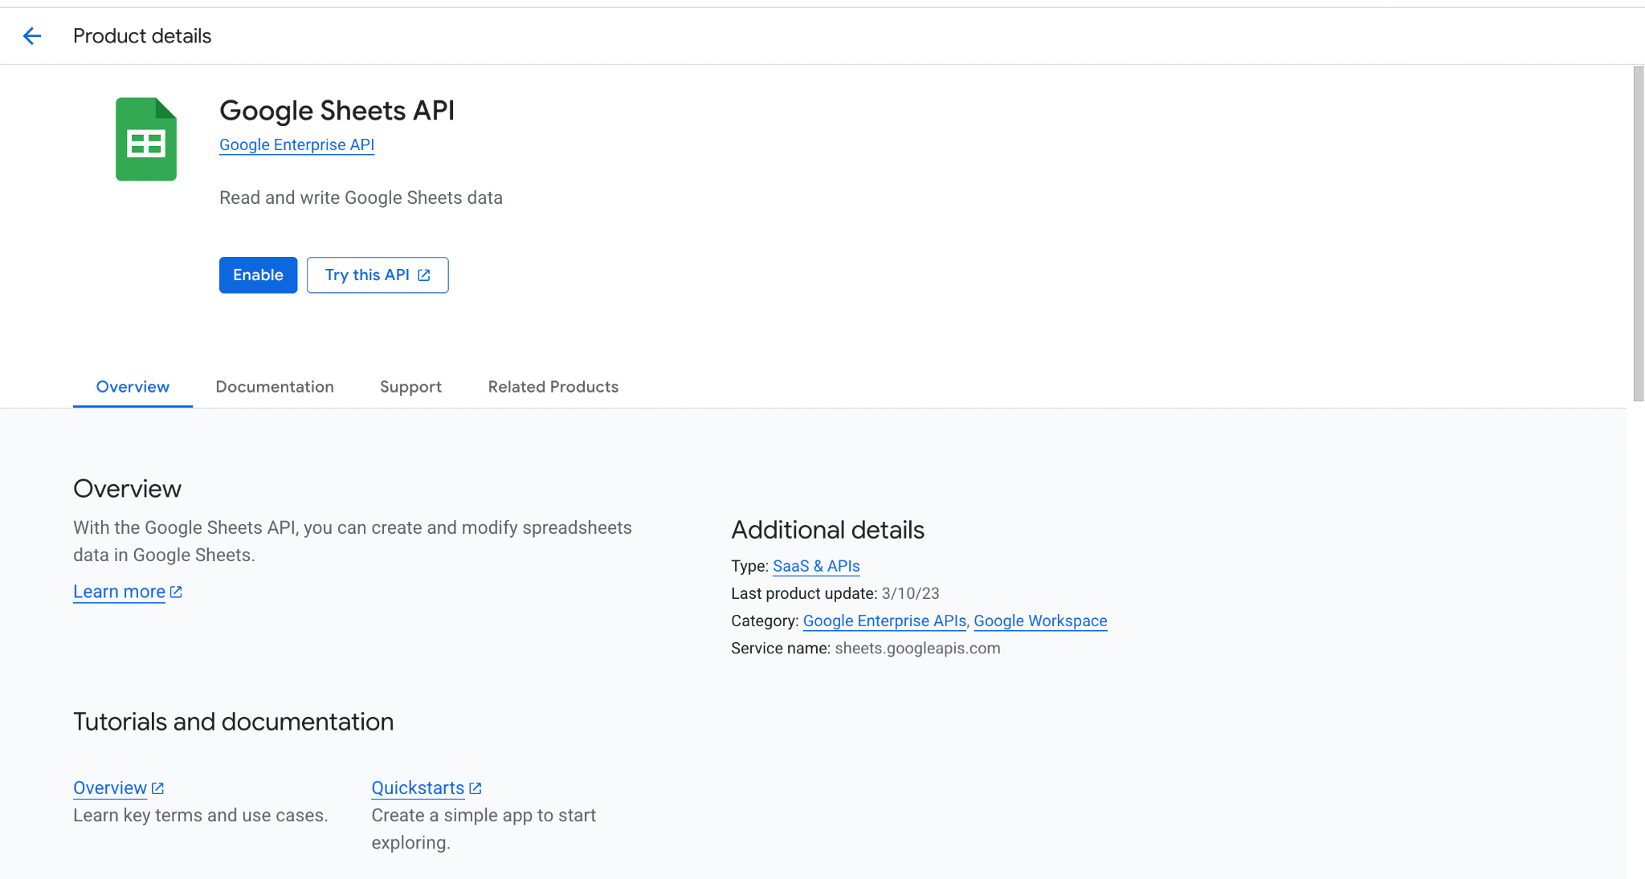

**Step 3: Go to n8n and create credentials for Generic Credential type >> Oauth2API**Make sure you copy the Oauth Redirect URL from here

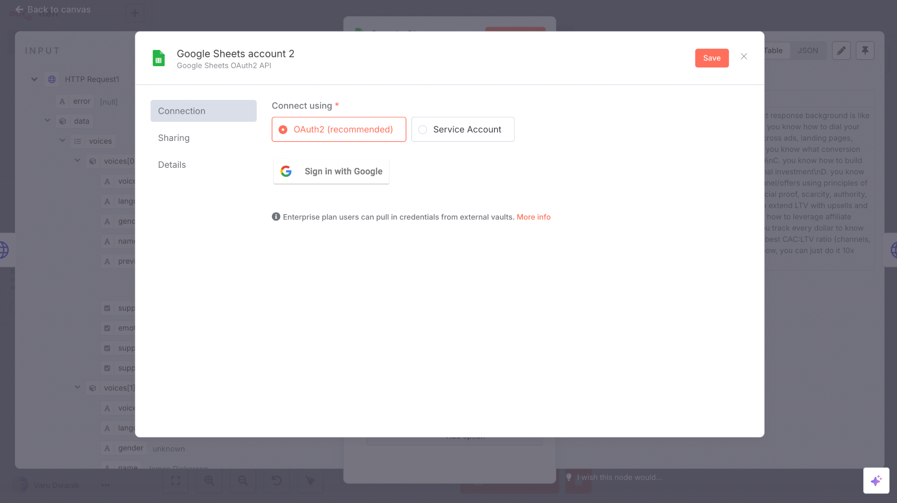

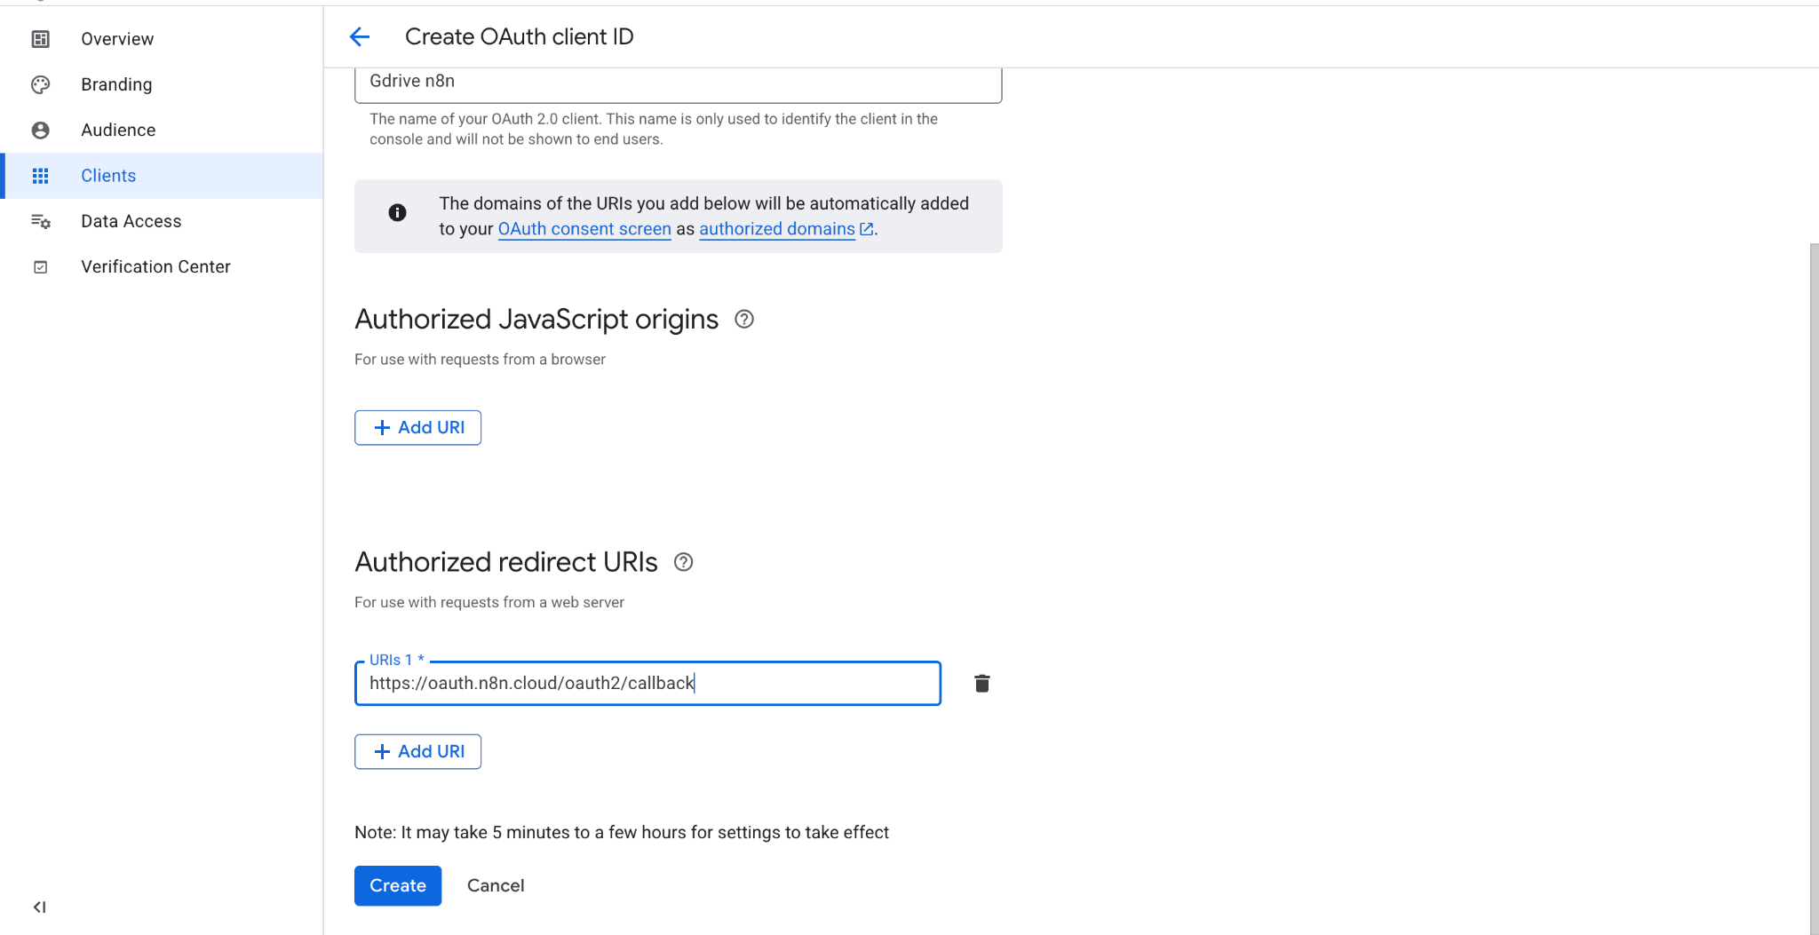

Then go to Google cloud console and select Create credential >> Oauth2   
  
Paste the Oauth Redirect URL from n8n here

**Step 4: Data access**Go to Gauth platform >> Select data access >> Add or remove scope (make sure you have the google drive scope on too)

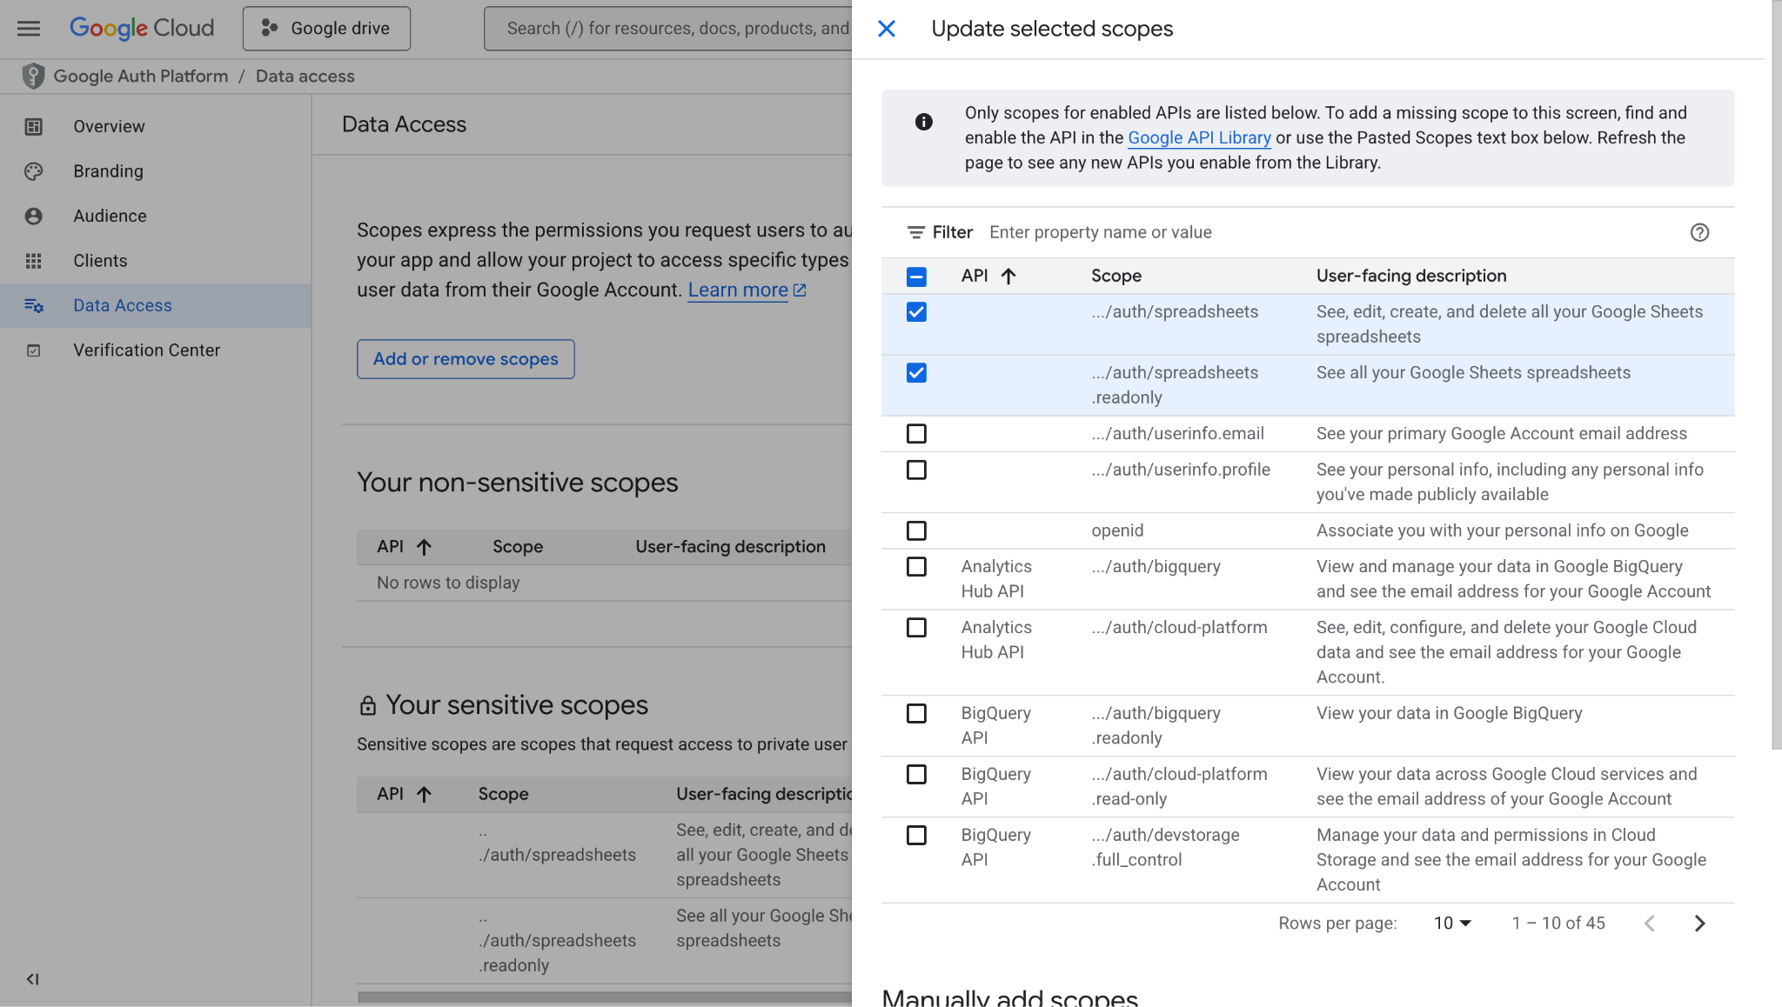

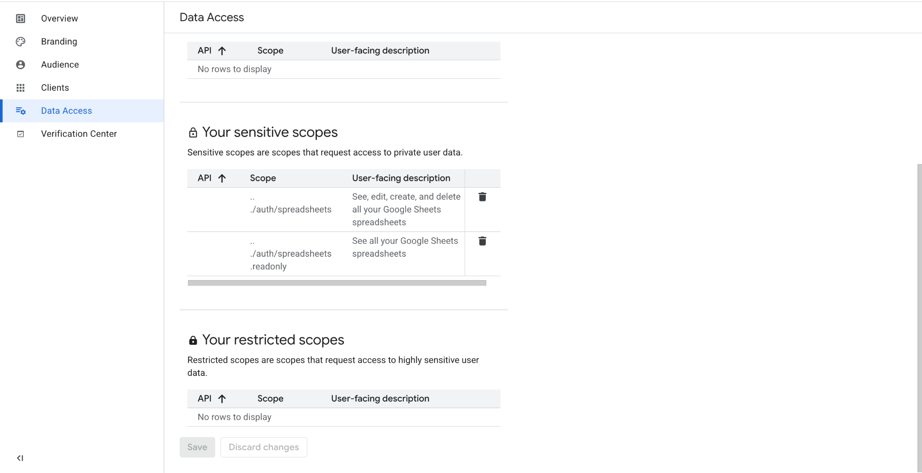

**Step 5: Press create**

You will see Client ID, secret created make sure you copy that from here and paste in in n8n Oauth2 API setup

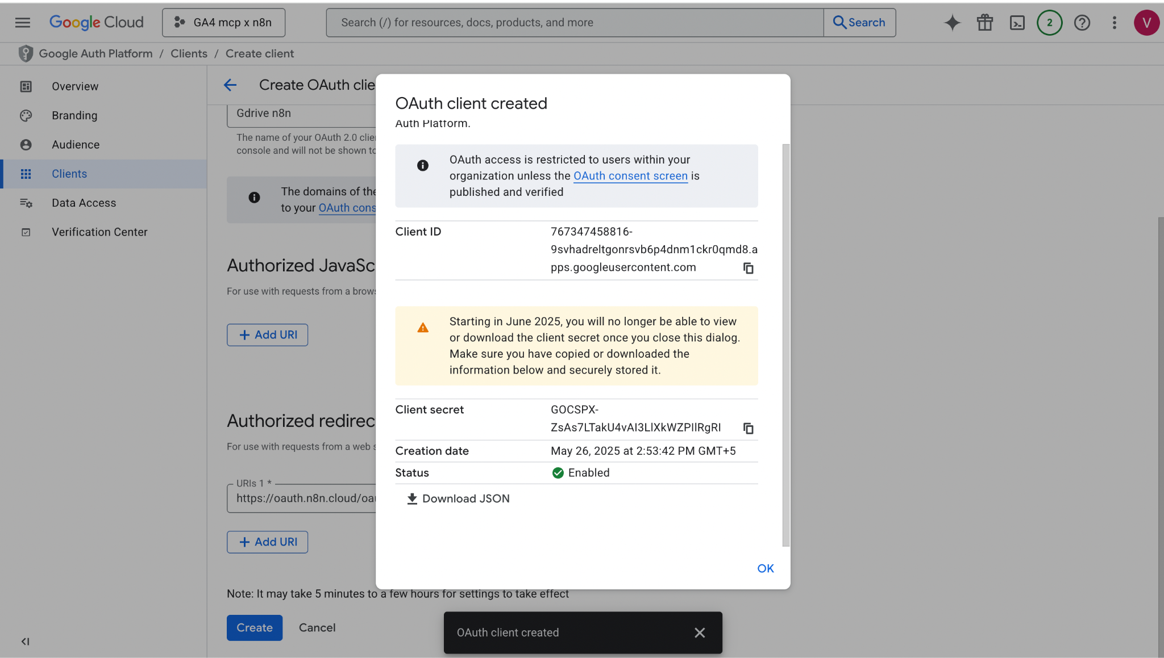

Step 6: Select add credential in the sheet and copy paste the client id and secret here

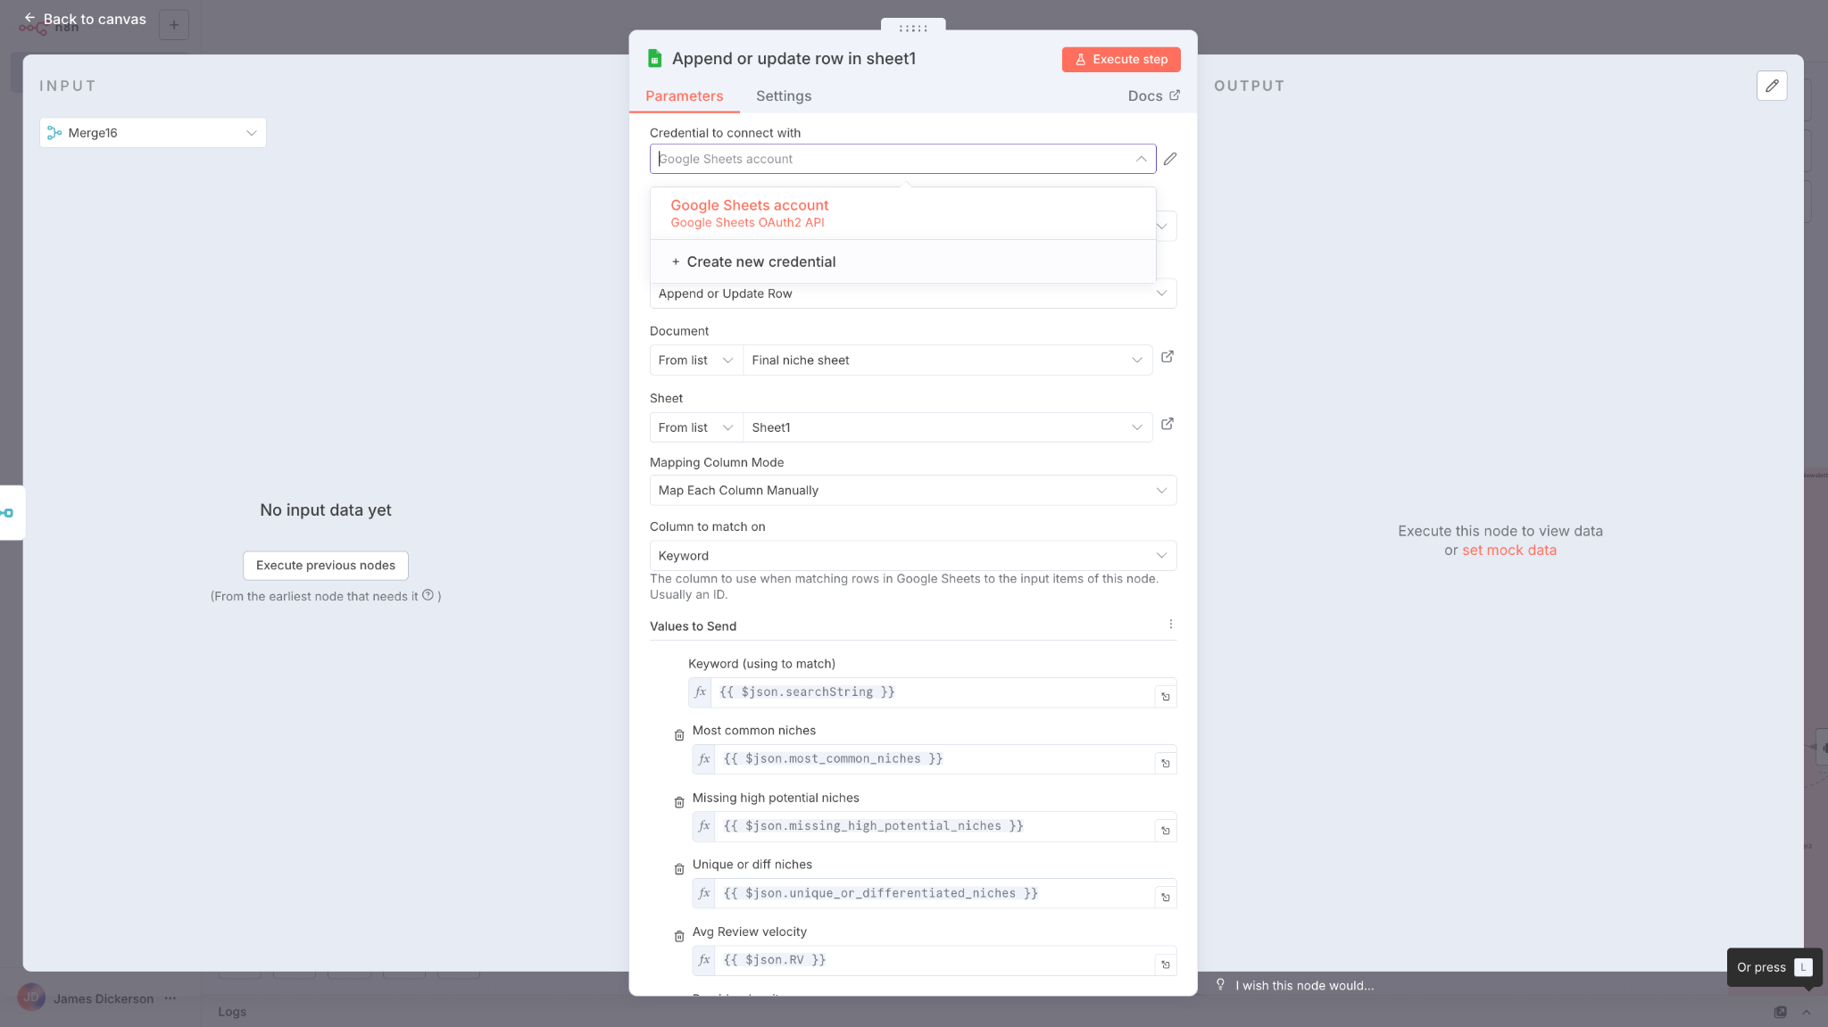  
  
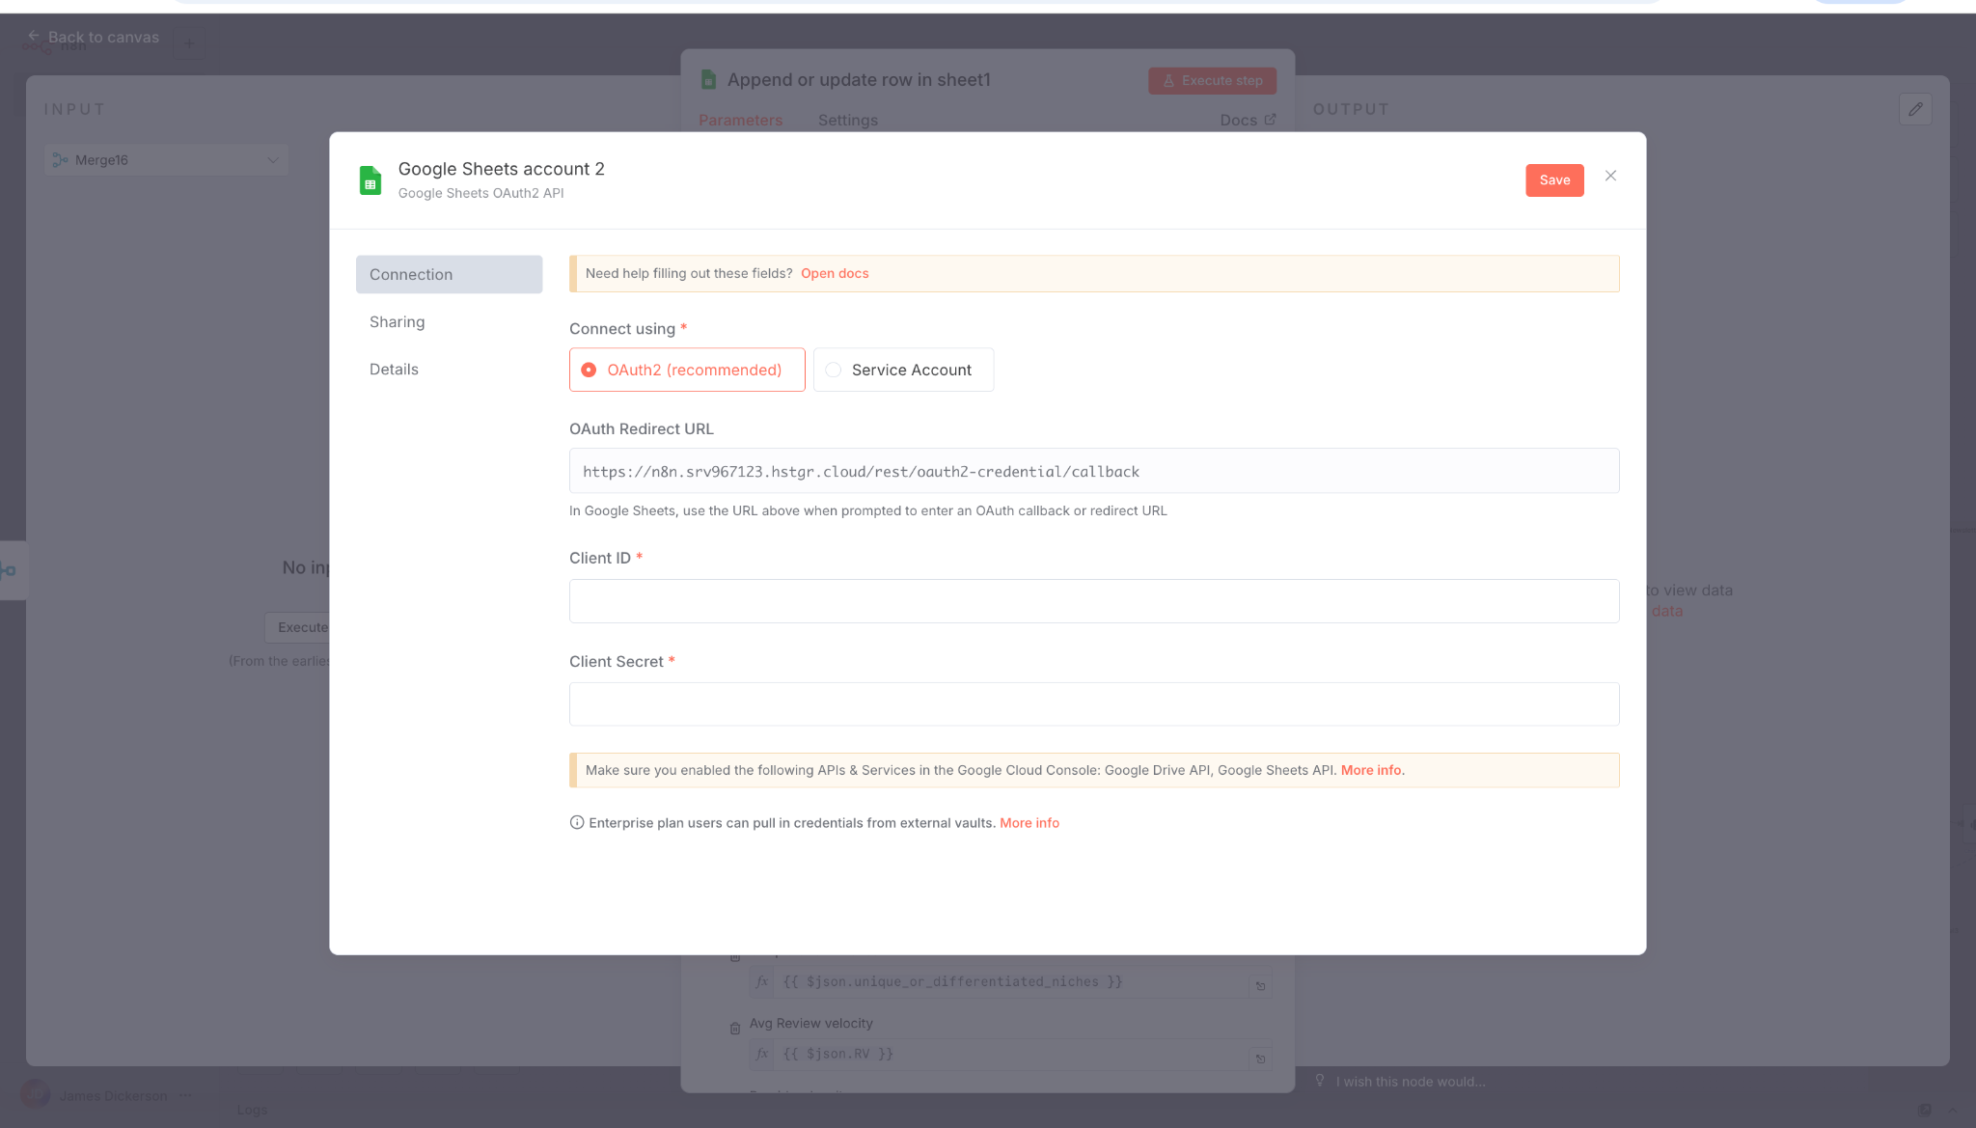

Note: Once done make sure you sign in with google as the last step for connection